June 24th, 2007
Hi
As you know, Nadine was here for four days. Last Sunday, she went to town to check the fitting for Leonie's wedding dress and again on Monday to pick it up. She left on Tuesday afternoon. I went to the airport with her in case there were baggage problems – she was over the limit for cabin baggage. Her friend Trevor also came.
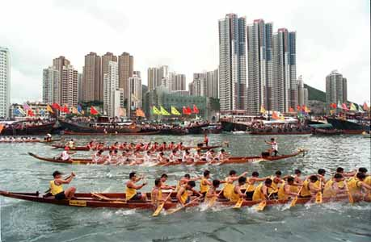
Tuesday was also a public holiday and the day for dragon boat races. The photo is not from this year’s races.
As I mentioned in last year’s letter at this time, HK has been getting some hot weather. Up to 33.3⁰C one day followed by a 33.5⁰C another. But not as hot as this time last year. However, not as bad as the 49-50⁰C in parts of Pakistan recently.

Exercise this week was the same as last week with 1 hr 40 min skipping and 7.5 km swimming.
For about three days, I have been 'spring’ cleaning the suite, the first time since being here. I concentrated on parts that the cleaners do not get to. There was a lot of dirt and dust in these places, especially behind the radio sideboard. While moving things, Nadine, I discovered a bag of clothes in a vacuum-sealed bag that you left here in January! I also threw out the old Adidas shoes that Gavin and I found in the rubbish bin outside a youth hostel in Denmark in 1994. They have served me well.
The report about the inquiry into government interference into the operation of the HK Institute of Education (teachers’ college) was released the other day. Arthur Li managed to escape major criticism only due to insufficient evidence but was regarded as not a credible witness. His deputy, Fanny Law, was severely criticised for interfering. The CE also announced his new ministers the other day and Arthur Li is out. It will be interesting to see what he does. He is unlikely to go back to CUHK (and there would be a lot of opposition to this anyway as many there do not like him). It also appears that his ambitions to become CE might be over.
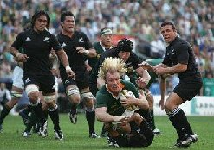
Yesterday was, as some people were saying, the dress rehearsal for the Rugby World Cup final, namely, the tri-nations test between NZ and SA in Durban. The ABs won 26 – 21, after being down 21 -12 with only 10 minutes remaining, but then they put on the pressure and scored two converted tries within four minutes.

In last year’s letter, I mentioned that the Lantau Cable Car opening was delayed because of mechanical problems. Well, as mentioned again, it is again not in use for the same reasons. Also in that letter, I read that the wounds from my operations were healing quite well.
That is it for now.

Cheers

